Report on the Status of Faculty Salaries at WSU
Faculty Salary Committee
October 2, 2007
(with final revisions, October 29, 2007)

Executive Summary

An ad hoc faculty committee was appointed by the Executive Committee of the Faculty Senate to provide a current portrait of faculty salaries at WSU, to identify problems, and to recommend solutions. The Committee found that the major problem is long-standing under-funding of salary increases by the state legislature. Chronic under-funding has made it difficult for deans and chairs to administer salary allocations in an equitable way. Salaries lag behind those of peer institutions and five universities in the State of Washington.

Goals of salary distribution can perhaps be summed up by “the four R’s”: Reward for outstanding performance, Retention of top-performers, Recruitment of promising new faculty, and Recognition for productive faculty. The overriding problem is that salary allocations, when adjusted for inflation, have been simply too small to satisfy all four goals. In practice, the first three goals get satisfied for a small subset of faculty while recognition for the bulk of the faculty gets short shrift. Many tenure-track faculty members receive salary increases at less than the rate of inflation. Variances in salary increases are large and tend to compound year after year for individual faculty members. Such compounding leads to enormous differences in salaries over time that can be said to be engendering a two-tier professoriate of “rewarded” and “unrewarded”. It is very demoralizing for productive faculty members to be continually unrewarded.

These problems of course are not unique to WSU. Inadequate funding of salary increases is causing similar problems at public universities across the country. However, WSU salaries in many colleges and departments have salaries with substantial lags behind those at peer institutions, and WSU salaries are lower than at many other institutions in Washington State.

We urge the President, Provost and Executive Vice President, and Regents to coordinate with the Faculty to address WSU’s salary problems. We offer three suggestions for external changes:

- Seek, in concert with the University of Washington, a one-time major appropriation from the state legislature to bring each institution’s average salary up to the average salary of its peers. Educate legislators as to the importance of the faculty and to the realities of how salary allocations are actually distributed in practice—with many productive faculty members frequently not receiving increases that meet the costs of inflation.
- Seek ongoing approval from the State Legislature to supplement salary allocations with local funds.
- Develop alternative, non-state sources of funding for salary increases through endowments. While difficult, this may provide the only long-term solution to the decline in state support for public universities.

We offer four suggestions for internal changes:

- Institute a new “Full Professor 2” rank to which full professors would be eligible for promotion. This would offer an additional opportunity for recognition of truly exceptional performance as well as a promotional salary increase.
- Set norms for market-place adjustments. Some recent adjustments appear extraordinarily large. Norms should be established in the Provost’s Office and made public.
- Reevaluate the current 30:40:30 salary allocation procedure that has been contributing to the increasing variance in salaries through compounding. Institute across-the-board salary increases in years when allocations are small (e.g., when the average salary allocation is less than the mean rate of inflation over the previous calendar year).
- Constitute equity redress committees of faculty members and administrators at regular intervals (e.g., every ten years). Such committees can address all types of equity issues, including salary inversion. Policy and procedures to redress inequities might form part of the Faculty Manual.

I. Background

On February 28, 2007, an ad hoc committee of the Faculty Senate was appointed by the Executive Committee of the Faculty Senate to prepare a report on the status of faculty salaries, to identify/address problems, and recommend solutions. The report in part updates information contained in a report of January 22, 2005 by the most recent past salary committee, headed by Robert Rosenman and John Cullen. The present report and its recommendations are directed to all faculty members, members of the administration and regents. Specifically, the committee was charged to:

1. Provide an accurate portrait of present salaries and update information in the previous report using services of Institutional Research.
2. Quantify the present status of faculty salaries, including salaries in upper ranks, and address issues of salary compression and inversion.
3. Examine the salary situation of temporary and non-tenure-track faculty members.
4. Based on the portrait, suggest potential solutions to identified problems.

The Committee was co-chaired by Gary S. Collins and Laila Miletic-Vejzovic, with other members Jan Busboom, Terrence Cook, Ken Duft, Emmett Fiske, Lisa Fournier, Michael Pavel and Elena Smith. The Committee met about 15 times between March and September 2007. We are indebted to Institutional Research (IR) for carrying out many analyses in a timely manner, and in particular to Coleen McCracken. Fran McSweeney and Karl Boehmke also provided valuable comments.

The Faculty Manual defines four faculties: Academic, Library, Extension, and Student Affairs. Section II reports salary information for instructional, full-time academic faculty. Salary issues connected with extension specialist professors are described in Section III. Section IV summarizes the information and describes two praiseworthy initiatives that the administration has undertaken over the past 10 years or so to compensate for under-funding of salaries by the state: Underwriting promotional increases at the level of 8-10% even when the legislature provided no funds for salary increases, and supplementation of state funds using local funds. Section IV also presents anecdotal perspectives. Finally, Section V gives the committee’s recommendations for external and internal action.

II. Portrait of Salaries of Academic Faculty at WSU

Numbers of various classes of faculty in recent years are tabulated in Subsection A. The current salary allocation system is described in Subsection B. Sources of salary funding are described in Subsection C. A detailed analysis of university-wide salary increases in September 2006 is presented as a case study in Subsection D. Subsection E provides a detailed examination of salary histories in one department to illustrate the cumulative impact of compounding of salary increases on individual faculty members over a 20-year period. The following subsections examine salary and inversion (F), comparison of WSU salaries with salaries at peer institutions (G) and other Washington State institutions (H). Results of a faculty satisfaction survey are presented in Subsection I.

- The faculty

Table 1 shows numbers of faculty members in various classes in recent years. Full-time non-tenure track faculty include instructors and clinical professors. Full-time temporary faculty include postdoctoral associates. As can be seen, the total number of faculty members is increasing by about 20 per annum, particularly in the category of temporary faculty.

Table 1. Faculty Members at Washington State University.
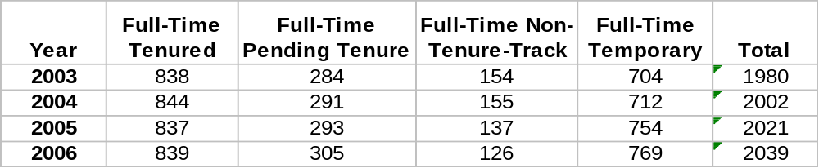

B. The current merit-based salary allocation system

According to the Faculty Manual, merit-based raises are to be allocated in 30:40:30 proportions, awarding “30 percent to professional development, 40 percent to superior merit, and 30 percent to extraordinary merit, equity, market adjustment”. This system came into effect in 1993.

Average merit-based salary increases for faculty at WSU over the long haul have hardly exceeded inflation. Between January 1993 and 2007, the average merit-based salary increase, adjusted for inflation, was slightly negative, -0.2% per annum. In addition, as shown further below, high or low salary increases tend to perpetuate for individual faculty members. This idea is illustrated in Figure 1 by trend lines for three hypothetical faculty members, the first receiving only the professional development allocation, the second receiving both professional development and superior merit allocations, and the third receiving also the extraordinary merit allocation. (The illustration does not include promotional increases that have been 8-10% in recent years.) Assumptions used in creating the illustration are detailed in endnote . As can be seen, salaries for the three faculty members would have fallen by 22%, fallen by 8%, or increased by 8% over the 13-year period of time. Also shown is the trend line for a hypothetical faculty member who received no raise at all, leading to a 30% loss of real income over that period of time. The figure suggests that merit-based allocations funded by the state and university are insufficient to maintain salaries of most WSU faculty members at the level of inflation. Of course, the illustration does not include promotional raises.

In the next section it will be shown that the average salary increase has only maintained rough parity with the costs of inflation over the past decade through supplementation of state-funded salary increases by the university using local funds.

C. Sources of salary funding
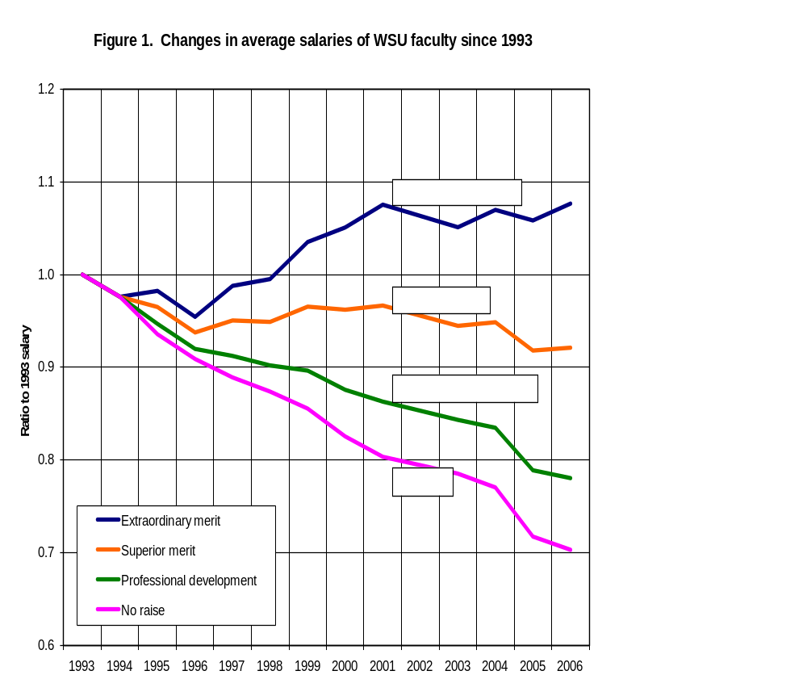
A qualitative illustration of changes in merit-based salaries of hypothetical WSU faculty members between 1993 and 2006, corrected for inflation using the CPI-U index. The Professional Development trendline illustrates the declining purchasing power of a hypothetical faculty member who received only the professional development allocation, year after year. The Superior Merit curve shows the corresponding trend for a faculty member who received both professional development and superior merit allocations year after year. The Extraordinary Merit curve shows the trendline for a faculty member receiving the entire average merit-based raise. The illustration assumed that 2/3 of faculty received only the superior merit allocation and that 1/3 received also the extraordinary merit allocation. The illustration excludes promotion, retention and market-place adjustments.
Until 1997, faculty salaries were funded solely by state appropriation. In 1997 and in some later years, state institutions were explicitly permitted by the legislature to increase the average raise beyond the state appropriation using local funds. WSU supplemented state appropriations in most years starting in 1997. The very positive consequence of such supplementation on salaries is illustrated in Figure 2. Considering the period 1989-2007, state funding of average WSU salaries has not kept pace with inflation, as shown by the lower trend line, leading to a decrease in purchasing power by more than 10%. Supplementation using internal university funds (mostly from student tuition) has closed the gap, as shown by the upper trend line, although the combination of state and university sources has not been sufficient to provide a meaningful increase in the average inflation-corrected salary.

Changes in inflation-adjusted average salaries over time. The contribution from the state has fallen steeply since the early 1990’s, and now provides 10% less purchasing power than in 1990. Internal funding of salary increases has made up much of the gap in state funding.

Figure 2. State and Internal Funding of Salaries adjusted for
Inflation
0.85
0.90
0.95
1.00
1.05
1.10
1989
1990
1991
1992
1993
1994
1995
1996
1997
1998
1999
2000
2001
2002
2003
2004
2005
2006
Including internal university funding
With state funding alone
The State Legislature approved a compromise biennial budget for 2007-2009 in April 2007, with merit based salary increases for WSU faculty approved for 3.2% for Sept 2007 and 2.0% for Sept 2008. Regrettably, local supplementation was effectively eliminated as an option for institutions without explicit authorization at that time. This is because WSU’s state allocation provided $1.45M less than the cost of salary allocations for the present biennium by excluding from the salary base those salary increases that had been locally funded without state authorization in the previous 2005-07 biennium.Error: Reference source not found In other words, the state allowed the use of unauthorized local funds to provide salary raises, but refused to accept the supplemented salary level as the basis for future state-funded salary increases. As a consequence, the university is saddled with a cost of $573,000 this year and an ongoing cost of $877,000 per annum beginning 2008-09, and in perpetuo. If state appropriations continue to fall behind inflation and local supplementation is not allowed, prospects for satisfactory future salary increases are dim.

D. An examination of the distribution of salary increases in September 2006.

The committee examined in detail the salary allocation that took effect in September 2006. The merit-based allocation funded by the legislature was 1.6%, with internal funds (from student tuition) added to bring the average merit allocation up to 3.0%. Percentages to be distributed according to the 30:40:30 formula were thus 0.9%, 1.2% and 0.9%. Separate funds were provided by the administration for promotions (84 faculty members received promotional raises of 10% in August 2006) and separate funds were allocated by the state legislature for retention raises. For comparison, the average 3.0% merit allocation was slightly less than the 3.2% rate of inflation for calendar year 2006.

At the Committee’s request, Institutional Research (IR) compiled a table of percentage salary increases of full-time instructional faculty members by unit and by ranks within each unit. In order to have comparable data, faculty who had been hired, retired or promoted in the year prior to September 2006 were excluded from the tabulation, leaving 827 full-time instructional faculty. The average allocation for academic, instructional, full-time faculty members continuing in rank in September 2006 was 3.49%. The discrepancy between the 3.0% merit allocation and observed average salary increase of 3.49% was examined by IR and attributed by them to several factors. We believe that the discrepancy is of interest, but not of significance.
At our request, IR also tabulated percentage salary increases for a broader group of faculty than just full-time instructional faculty (e.g., including library and extension faculty). This more comprehensive group comprised 1168 faculty members continuing in rank. The frequency distribution of percent salary increases for this group is shown in Figure 3. As can be seen, the variance of individual salary increases is quite large. Excluding the 0% and 10+% outliers, the mean of the distribution is 3.0% and the standard deviation is 0.7%. It can also be seen that the percentage of faculty members continuing in rank who received raises smaller than the contemporaneous rate of inflation (3.2%) was 62.4%. A significant “tail” of large salary increases is observed in the range of 5-10% raises, and an additional 44 faculty members received raises in excess of 10%, including 13 with increases greater than 20% and one with a raise of 48%. This salary distribution data represents salary increases received by 96% of continuing faculty; with the 4% of faculty who were promoted not included in this analysis, some of whom may have changed responsibilities or have received large merit and/or retention increases in addition to promotional increases.

Based on the variance of salary allocations, one might suppose that large numbers of faculty members are not productive. However, procedures in the Faculty Manual for allocating salary increases and data presented in Figure 3 belie that belief. Only 21 individuals, or 2% of the faculty, failed to receive even the professional development allocation of 0.9% in September 2006, possibly for reasons not connected with the merit raise system. Only 33 individuals, or 3% of the faculty, received solely the professional development allocation. Thus, 95% of continuing faculty members received at least some recognition of “superior merit” by chairs and directors.

We summarize this study of salary distributions of faculty continuing in rank as follows:

- 95-98% of faculty were rated in their annual merit reviews as exceeding the expectation for professional development.
- The variance in raises about the mean raise of 3.0% is large.
- More than 60% of productive faculty members received salary increases at less than the 3.2% contemporaneous rate of inflation.
Figure 3. Frequency Distribution of Salary Raises in September 2006
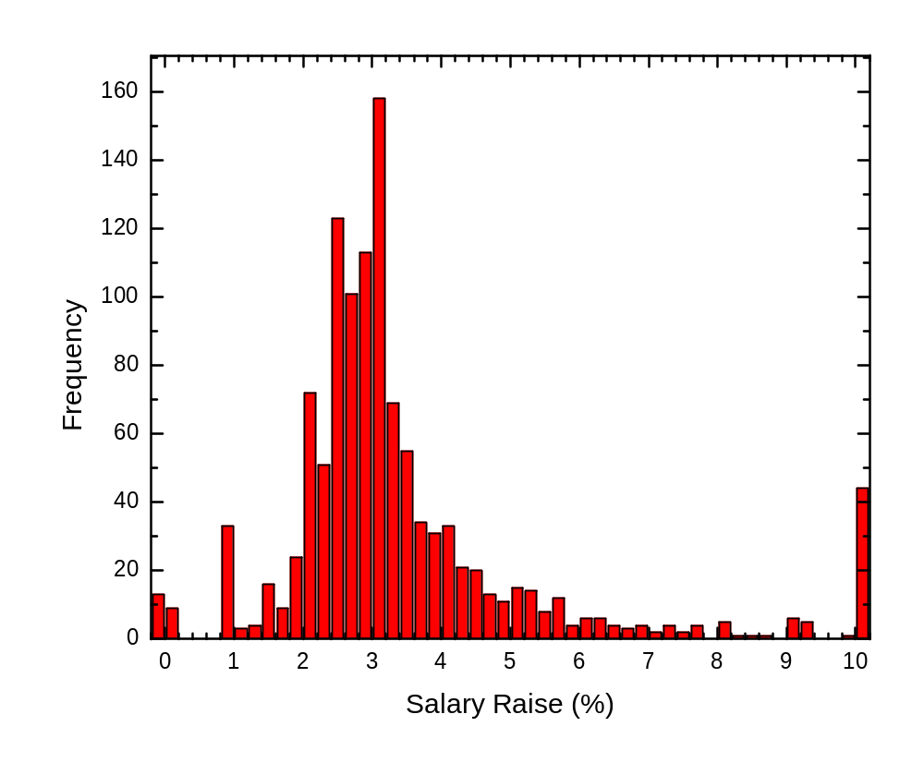For 1168 faculty continuing in rank the average merit-based increase was 3.0%. 21 faculty members did not receive even the professional development allocation. 33 received only the professional development allocation (0.9%). 1114 received at least some allocation for superior merit. 44 faculty members received increases in excess of 10%, which appear to be attributed to non-merit based marketplace or equity adjustments. One faculty member received an increase of 48%.

E. Case study of salary increases in one department: Compounding increases over time

The committee was provided with an historical study of individual salary increases in a science department from the time a faculty member in the department joined WSU in 1985 up to the present (Figure 4). The data include merit-based, promotional, and retention increases. The data were corrected for inflation using the CPI-U index and normalized to each faculty member’s starting salary so that one can observe the growth (or decline) of each faculty member’s real income over time. As can be seen, about 1/3 of faculty in this unit had growths in real incomes of order 3% per annum while 2/3 had growths ten or more times smaller. This demonstrates how large variances in salary increases get compounded over time. Clearly, individuals who were rewarded well in one year were also rewarded well in other years. At the same time, 2/3 of faculty experienced what might be called “salary stagnation”.

F. Salary inversion as a consequence of large variances and compounding

Large variances in salary increases and compounding over time lead to salary inversion. As a metric, we consider salaries in a unit to be inverted if (1) the highest assistant professor salary exceeded the lowest associate professor salary, or (2) the highest associate professor salary exceeded the lowest full professor salary. Salary tables for 2006 provided by IR showed that 33 departments out of about 70 departments and other non-departmental units were experiencing salary inversion. Promotions or retention adjustments may lead to inversion. Inversion may also arise when market-place considerations cause new hires to be given higher salaries than were the norm for earlier hires. Salary stagnation, increasing differences among salaries over time, and salary inversion demoralize many faculty members.
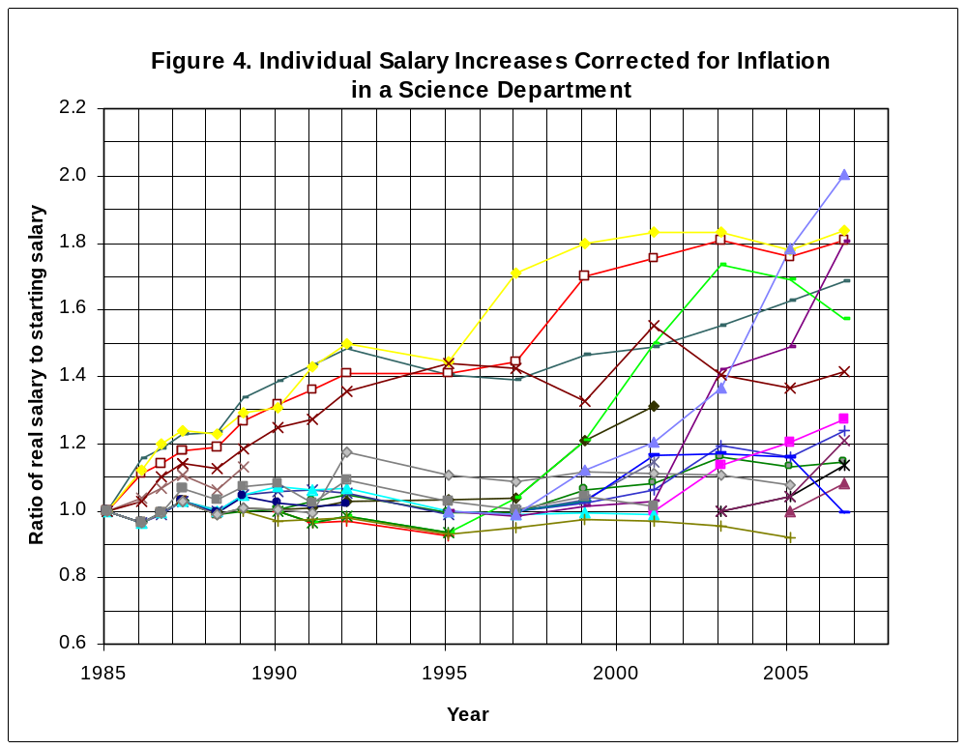
Historical changes in inflation-adjusted salaries of individual faculty members in a science department, normalized by individual starting salaries. Salaries of faculty members already present in 1985 are normalized to 1, with salaries for faculty members hired later initially fixed at 1. The trend lines include promotional increases.

G. Comparisons with peer institutions

WSU faculty salaries continue to lag behind those at peer institutions, as shown in Figure 5. Using data from the 2006 OSU survey, the lag behind peers averaged over all ranks was 12.3%. The lag in 2006 was greatest for full professors, at 15.2%. As can be seen from the figure below, averaging over the seven year period of review 2000-06 gives lags of roughly 15%, 8% and 5% for full, associate and assistant professor ranks. This ordering of lags--from large to small for full to assistant professors--indicates that salaries are more compressed or inverted between ranks at WSU than at our peer institutions.

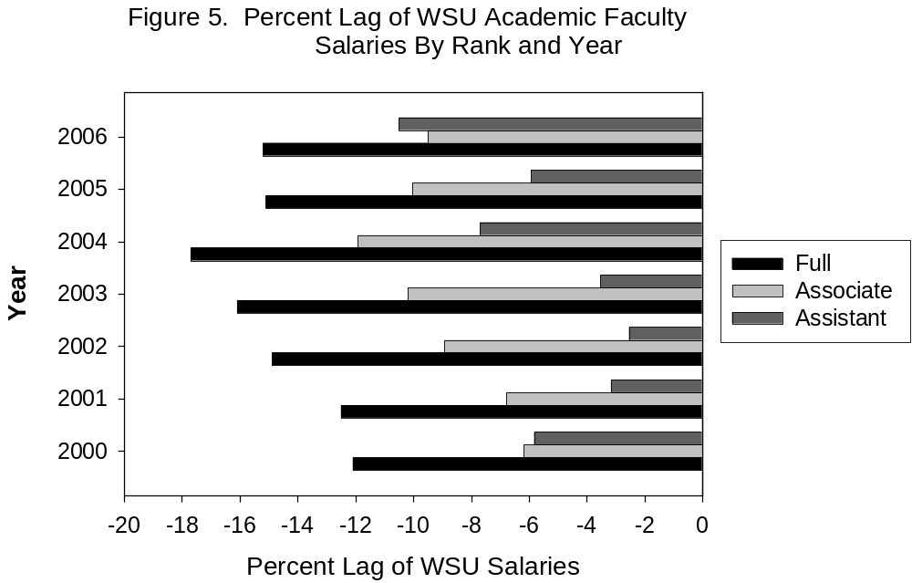

Table 2 shows lags of salaries of academic faculty behind peers broken down by colleges. Error: Reference source not found As can be seen, lags are in the range 10-20% for most colleges, in particular those having many faculty members. The professional colleges have smaller lags.

Table 2. Comparison of WSU Academic Faculty Salaries with Peers, by College

College | Percent Lag Behind Peers
Business | -19.7
Sciences | -13.5
Liberal Arts | -13.3
Engineering | -11.8
Agriculture | -10.4
Education | - 9.6
Pharmacy (Pullman and Spokane) | - 6.2
Nursing (Spokane) | - 3.2
Veterinary Medicine | + 0.1

Departments having greatest and least lags are listed in Table 3.Error: Reference source not found Only three out of about 70 departments have salaries leading their peers. A great lack of uniformity in lags is observed among departments within individual colleges; e.g., in the College of Sciences, Statistics has a lag of -46.9% and Physics and Astronomy has an average lag of only -1.3%. Reasons for such large differences are unclear.

Table 3. WSU Faculty Salaries in 2006 by Department Compared with Peers

Department | Percent Lag Behind Peers  ( > 20.0% lag)
Theater | -54.9
Statistics – Sciences | -46.9
Statistics – CAHNRS | -41.0
Marketing | -33.0
Women’s Studies | -32.9
Food Science | -27.1
Political Science | -24.6
Comparative Ethnic Studies | -24.1
Finance, Insurance & Real Estate | -23.9
Management & Operations | -23.5
Mathematics | -23.4
History | -21.9
Accounting | -21.5
Philosophy | -20.4
Community and Rural Sociology | -20.2
Department | Percent Lag Behind Peers  ( < 8.0% lag)
Entomology | - 7.7
Environmental Science and Regional Planning | - 7.4
Interior Design | - 6.5
Plant Pathology | - 6.3
English | - 5.0
Horticulture and Landscape Architecture | - 4.4
Pharmocotherapy (Pull and Spo) | - 3.9
Nursing (Spokane) | - 3.2
Crop and Soil Science | - 2.3
Speech and Hearing Science | - 2.1
Physics and Astronomy | - 1.3
School of Electrical Eng and Computer Sci | - 0.9
Sociology | + 0.2
Biological Systems Engineering | + 4.1
Management Information Systems | + 5.2

Significant differences were observed between entries in Table 3 and in the equivalent Table 1 from the 2005 salary reportError: Reference source not found that was based on 2003 salary data. Since peer comparisons are made using weighted averages of salaries in the different ranks, the differences are most likely caused by changing salary profiles due to hires, promotions and retirements. Therefore, college level lags in Table 2 are probably more stable measures on which to base any equity adjustments.

H. Comparison with other Washington State institutions

Figure 6 compares average 2006 salaries of full professors at WSU with those at other Washington State universities having greater average salaries (using AAUP data). As can be seen, WSU salaries ranked sixth in the state, with the greatest lag behind the University of Washington (UW), the other Carnegie Research I University in the state.

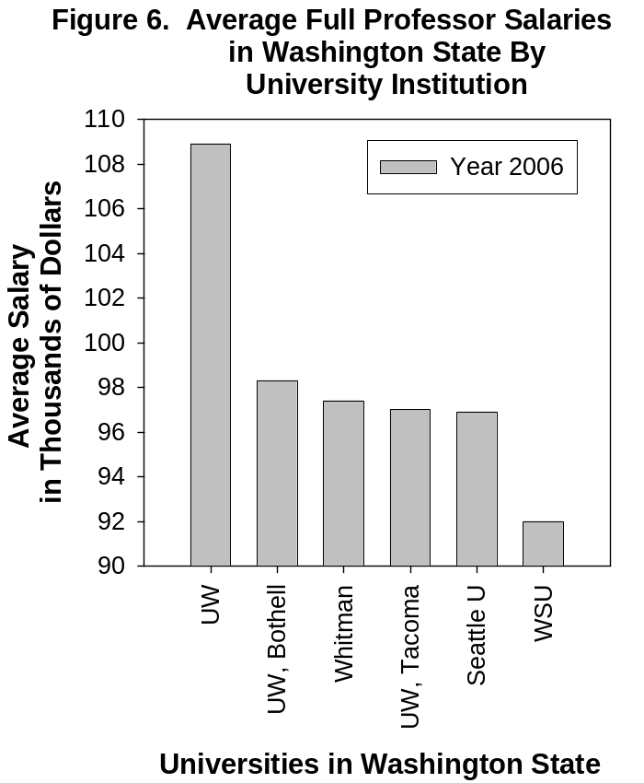

In Table 4 are shown average salaries for all professors at WSU and UW from 1997 through 2006 (not just full professors). Also tabulated are ratios of the average salaries. As can be seen, the ratio of salaries has held steady at about 84% over the entire period. Thus, the State has not been favoring UW over WSU in the measure of salary increases. Alternatively, it might be written that there is comparable salary stagnation at both institutions.

Table 4. Comparison of average salaries at UW and WSU

Salaries | 1997-98 | 1999-00 | 2000-01 | 2001-02 | 2002-03 | 2003-04 | 2004-05 | 2005-06
UW | $63,130 | $68,463 | $73,237 | $76,777 | $77,613 | $79,894 | $83,530 | $86,800
WSU | $53,899 | $58,533 | $61,383 | $64,707 | $64,901 | $65,974 | $68,365 | $72,702
WSU/UW | 85.4% | 85.4% | 83.8% | 84.3% | 83.6% | 82.6% | 81.8% | 83.8%

I. Faculty satisfaction survey

A survey of faculty members was carried out by Kenneth Duft and Sanatan Shreay in Spring 2007 to assess attitudes towards career, promotions and salary increases. The survey was sanctioned and endorsed by the Faculty Senate. The survey was distributed to 627 instructional faculty members using the University’s faculty listserver and had a 27% response rate.

Three questions were asked: “In general, are you satisfied or dissatisfied with:
- The progress in your overall academic career.”
- Your promotions over time.”
- Salary increases you have received in your current position.”

Responses are summarized as percentages in Table 5. As can be seen, there was general satisfaction with career progress and promotions, but nearly half of the respondents expressed dissatisfaction with salary increases, and almost one quarter expressed great dissatisfaction.

Table 5. Faculty survey of career, promotional and salary satisfaction

 | Very satisfied | Somewhat satisfied | Neutral | Somewhat dissatisfied | Very dissatisfied
Career | 41% | 36% | 9% | 11% | 3%
Promotions | 35% | 25% | 23% | 8% | 9%
Salary increases | 13% | 25% | 15% | 24% | 23%

III. Portrait of Salaries of Extension Specialists

Extension faculty possess academic credentials essentially identical to those of academic faculty carrying out teaching and research. Extension faculty are also members of academic disciplinary units and are subject to evaluation criteria for promotion, tenure and salary allocation that are generically similar to those of their academic faculty counterparts in the same units. Extension specialists carry major service-related responsibilities, but a percentage of their appointments often require them to teach and carry out research in the same way as their academic faculty counterparts. Extension specialists E-4 with research and teaching duties hold professorial ranks. Consequently, they report both to academic chairs and to extension administrators.

While extension faculty and their academic counterparts have similar responsibilities, Table 6 shows that there is a significant salary lag for extension specialists E-4 relative to their academic counterparts, as shown in Table 6. Salary differences for persons that have significantly similar performance expectations may be grounds for an examination of salary equity.

Table 6. Salary lags of Extension Specialists Behind Academic Counterparts
Department or Unit | Salary Lag of Extension Specialists E-4 (2006)
Animal Science | -16%
Crop and Soil Science | -26%
Sch. Of Economic Sciences | -18%
Entomology | - 6%
Food Sci. and Human Nutrition | +18% *
Natural Resource Sciences | - 3%
Hort. & Landscape Arch. | - 5%
Human Development | -24%
Plant Pathology | -10%
Community & Rural Society | +10%
Average** | -15%
* One individual only
** Average for 12 extension specialists and 73 academic faculty.
IV. Summary

The foregoing salary portrait offers a grim picture for many faculty:

- Almost all faculty are highly productive, as evidenced by a detailed examination of salary increases effective September 2006, in which 95% of faculty members were awarded at least some “superior merit”.
- However, average salary increases of faculty have barely kept up with the costs of inflation over many years. Many faculty members receive increases below the rate of inflation, obviously a source of great demoralization—especially when others are rewarded well. And high and low increases tend to compound over time. About half of the respondents to a faculty satisfaction survey expressed dissatisfaction with their salary increases, and about one quarter expressed major dissatisfaction.
- One third to one half of departments and equivalent units are experiencing salary inversion. Such situations compound dissatisfaction of faculty members already experiencing stagnant or declining real salaries.
- Since about 1995, the State has underfunded salary increases in real terms by 10%.
- Since about 1997, the University has tried to supplement salary increases using local funds. Such supplementation in some years has increased the salary basis of the university--provided it was accepted by the state. This was a very favorable circumstance. But recently, the State refused to allow WSU to supplement its salary allocations with local funds that had not been already explicitly approved, saddling the university with an ongoing expense of the order of $0.8M that the university must meet. Future internal supplementation is therefore strongly precluded without advance state approval, making it unclear that the university will be able to sustain raises that come close to meeting the costs of inflation—not to mention providing genuine raises to the vast proportion of its faculty that are highly productive.
- Comparisons with peer institutions show that average WSU salaries in the six nonprofessional colleges lag by 12-20%. The lag is the worst for full professors, at 15%. Only six out of about 70 units have salaries that lead peers at all, while nine lag by more than 30%.
- Comparison of full professor salaries with those at other institutions in the State of Washington shows that at least six other universities have higher salaries than WSU. The average salary at WSU lags behind that of the University of Washington by about 16% in 2000.
- When evaluating merit of performance, extension service portions of appointments may be undervalued in comparison with teaching and research.

The gravest problem is inadequate funding by the state. State funding of faculty salaries has fallen 10% behind inflation since 1995. University supplementation since then has helped to keep the average salary increase close to 0% in real terms. But the large variance in, and compounding of, raises, creates a zero-sum game in which some are rewarded and others are not.

The administration deserves particular praise for two initiatives that it has instituted in the past decade:

- Promotional increases. The university has funded promotional increases out of internal funds at the level of 8%, and more recently 10%, over the past decade or so, even when no state funds were allocated for salary increases. In the current era of ~3% inflation per year, this makes promoted faculty members feel valued. It should be understood that these promotional increases are the largest salary increases—in real terms – which most faculty members are likely to ever receive. We strongly recommend that the administration continue to provide ~10% promotional increases as these uniform increases have a positive influence on salary inversion. Standardized promotional increases also eliminate the enormous demoralization that some earlier faculty experienced in so-called “dry” promotions, in which no general salary allocation was provided by the state and no promotional increase was awarded. Dry promotions occurred occasionally from the 1970’s to the early 1990’s. Sustaining uniform promotional raises will help reduce the incidence of salary inversion.

- Supplementation of state funds for salary increases. The university has supplemented salary increases funded by the legislature with funds generated internally (mostly from student tuition) to reach levels comparable to the contemporaneous rate of inflation. Thus, the 1.6% salary increase funded by the legislature for Sept 2006 was supplemented locally by 1.4% to make a total average raise of 3.0%. This commendable action by the university administration helped to maintain an average salary increase at close to the rate of inflation. Before 2006, funds allocated internally by the university served to increase the salary basis of the university, with subsequent raises granted by the legislature based on that basis. Thus, one-time commitments of funds led to ongoing salary increases--a very favorable outcome. However, the state ruled in April 2007 that internally funded increases from the last biennium that were not explicitly authorized would not be counted in the basis for future salary increases. As a consequence, the university has in effect been saddled by the legislature in the latest biennial budget with an ongoing bill to continue to subsidize salaries of its faculty members--a very unfavorable outcome. Supplementation in the future appears doomed without explicit approval of the legislature.

The above underwriting of promotional increases and supplementation of state-funded salary allocations in recent years by the administration have been very effective at sustaining real salary levels and deserves praise.

What are the negative consequences of chronic under-funding of raises? The salary allocation is too meager to satisfy the four salary allocation goals:

- Reward for outstanding performance.
- Retention of high-performing faculty who might otherwise leave.
- Recruitment of outstanding new faculty members.
- Recognition for the remaining large majority of productive faculty.

In practice, administrators satisfy the first three goals, and give short shrift to the fourth. It is important for all faculty members at WSU to realize that many of their colleagues have been experiencing stagnant or falling real incomes.

Other perspectives about the consequences of chronic under-funding are illustrated in the following anecdotal comments provided to the committee:

- “Full professor salaries are cannibalized to keep entry at market with the hope that some will stay. This is a revolving door as we have fewer fulls than our peers do, so we need more replacement”.

- “I analyzed raises in my fourth year at WSU, just after coming up for tenure review with a major NSF grant in hand. My analysis showed that I had received the lowest raise in my college in that year. Inquiring of my chair, I was informed (in writing, copy provided on request) that my raise was low because my “starting salary had been relatively high”. Particularly since I came as an associate professor, and therefore missed one promotional increase, it absolutely stinks that the salary I negotiated when hired would not be used as the basis for future salary raises. ”

Of course the administration should make best efforts to attract and retain talented faculty members. However, with average salary increases barely matching inflation, the end result has been that some faculty members experience significant raises while the rest experience salary stagnation or worse. This reduces harmony among the faculty.

Unfortunately, the situation at other institutions around the country--in particular state institutions--is not much different. The upbeat heading in a recent article in the Chronicle of Higher Education, “For the First Time in 3 Years, Faculty Salaries Beat Inflation”, belies an obvious assessment of major problems in the article: “One year cannot reverse discouraging trends that have developed over decades.”

V. Recommendations

The Committee recommends that the President, Provost and Executive Vice President and Board of Regents seek to increase the absolute size of the salary “pie”. This may require new ways to approach the State Legislature. The committee reached consensus on three recommendations for external action:

- Seek, in concert with the University of Washington, a major one-time allocation from the state legislature to bring each institution’s average salary up to the average salary of its peer institutions. Find new ways to educate legislators to the role of the faculty in universities and about how salary raises are distributed in practice—with many or most faculty members not even receiving salary increases that match costs of inflation. Legislators need to understand that the vast majority of faculty members are highly productive.

- Seek ongoing legislative approval for WSU to supplement state salary allocations with local funds.

- Work to increase endowments targeted to supplement faculty salaries. This may be the only long-term solution in an era of declining legislative support for funding universities. The problem is that it is easier to get funding for more visible endowed professorships than for routine increments of salaries for the rest of the faculty.

For internal changes, we offer several recommendations to the administration and faculty:

- Continue, as possible, to supplement state-funded salary allocations with local funds that bring the average salary increase up to at least the average rate of inflation in the most recent calendar year. Also, continue to subvent promotional increases at the level of about 10%, about 7% above the contemporaneous rate of inflation. In case inflation increases significantly, maintain a promotional increase at a level of about 7% above the contemporaneous rate of inflation.

- Institute a second faculty rank at the full professor level, making the present full rank “Professor 1” and the new, higher rank, “Professor 2”. Professor 1 would be the rank for promotion from associate professor. Professor 2 would be a rank to which Professor 1 faculty could be promoted after having demonstrated additional accomplishments. The new rank would offer an additional promotional opportunity for current full professors. Existence of the Professor 2 rank would stimulate faculty members to continue to excel. This new fourth professorial rank would be completely independent of, and separate from, the present special rank of Regents Professor.

The committee was split on this recommendation. Some members felt that creating a new professorial rank would just help the “rich get richer” by offering another avenue for a salary increase. Others felt that highly productive faculty members are likely to receive new high awards in any case, and that it would be better to have such rewards bestowed through a carefully vetted promotion process than in the way it appears to be carried out at present.

- Establish procedures to constrain market-place adjustments. In the salary allocation distributed in September 2006, in which the average raise was 3.0%, 44 faculty members received increases in excess of 10% and 13 in excess of 20%. These very large adjustments appreciably reduce raises that other faculty members might have received. If the 44 faculty members receiving salary increases in excess of 10% had only received average increases of 3%, then the funds made available could have been used to enhance salaries of roughly 430 faculty members by an amount of the order of 1%. We recommend that a process be established in the Provost and Executive Vice President’s Office to independently review recommendations for large salary increases by chairs and deans.

- Reexamine the current 30:40:30 salary allocation process that has been in place almost 15 years. We recommend that the Faculty Affairs Committee of the Faculty Senate consider revising the procedure. In years in which the overall salary allocation is smaller than some stipulated trigger level, across-the-board salary increases would appear appropriate. We recommend that such a procedure apply in years when the average salary allocation is less than the rate of inflation in the most recent previous calendar year. This procedure will help to ensure that productive faculty members receive at least a modest increase. Comparison with the average rate of inflation in the most recent year, rather than with some specified percentage increase, would keep the procedure useful in eras when annual rates of inflation are very high or low.

An alternative, more radical, suggestion that we support is to provide a common equal-dollar salary increase to all faculty members in years in which the allocation is below the rate of inflation. Such a salary distribution will help reduce the large variance in salaries.

It should be noted that, according to the Faculty Manual, the President may seek an alternative allocation in any year.

- Address problems of salary inversion and equity issues via equity redress committees that are constituted periodically (e.g., every 10 years). Such a committee was formed from a panel of distinguished faculty members in the mid-1980’s, selected by the President from a list provided by the Faculty Senate. They received petitions from individual faculty members and from units. Empowering such a committee once every decade or so will help to address some of the more egregious inequities. To ensure that such period reviews take place, procedures should be codified in the Faculty Manual.

Other issues that the committee wished to address, but for which time did not permit, include the status of librarian, temporary and off-campus extension faculty members. Another thought, when comparing WSU and peer salaries at the unit level, is to examine the relative numbers of faculty in the different ranks at WSU and peer institutions. The next salary committee might consider those and many other issues.

Notes

Faculty Salary Committee: Final Report, January 22, 2005.
Numbers provided by Human Resource Services.
Faculty Manual, Section III.D.6.a, http://facsen.wsu.edu/faculty_manual/documents/Section_III_002.doc, page III-25.
Average salary increases were compounded using WSU salary allocation history data dating back to 1981 (from Institutional Research, “Salary Increase History, by OFM Employee Type”, source: Budget Office Salary Report, File: DB_E0410.XLS.) Inflation data (CPI-U, all urban consumers) were taken from the Bureau of Labor Statistics, ftp://ftp.bls.gov/pub/special.requests/cpi/cpiai.txt. Between Jan 1993 and Jan 2007, average merit-based salaries, in nominal dollars, increased by the factor 1.430. Over the same interval, inflation increased by the factor 1.469. Thus, average real salaries changed over 14 years by the factor 1.430/1.469= 0.973, from which one finds that the average real salary declined per annum by 2.7%/14= 0.2%. The extent to which the above data include retention, market-place and promotion raises is unclear since it varied from hear to year.
It will be shown below (Figure 3 and discussion of the salary allocation in September 2006), that only very few faculty members received solely the professional development allocation, and so will now be ignored in estimating raises for most faculty members. We assume this remained the same also in other years. For the illustration shown in Fig. 1, we assume that faculty members either uniformly receive the full superior merit allocation in an ongoing way, at 30+40%= 70% of merit worthiness, or the full extraordinary merit allocation in an ongoing way at 30+40+30%= 100% of merit worthiness. (The supposition that an individual faculty member receives the same type of salary allocation year after year is supported below by Fig. 4 and discussion.) To simulate Fig. 1, we assume that 2/3 of faculty members receive 70% and 1/3 receive 100%. Finally, we assume for simplicity that salaries of the two groups are equal. With these assumptions, one can work out the raises for the 2/3 and 1/3 fractions of faculty. The result is that, in a year in which the average raise is x (in percent), raises for the 2/3 and 1/3 groups are, respectively, 0.875 x and 1.25 x. For example, for the salary distribution in September 2006, in which the average raise was 3.0%, and with the actual distribution of raises shown in Fig. 3, the simulation gives raises of 2.63% for the 2/3 group and 3.75% for the 1/3 group. Those results are qualitatively representative of the standard deviation of the actual distribution about the mean of 3.0%. Fig. 1 was prepared by propagating these calculations over the years using information on historical salary raises (cf. citation in endnote Error: Reference source not found).
Washington State University, 2007-2009 Biennial Budget, State Conference Committee Operating Budget (distributed following release of conference report on operating budget by legislative leaders on April 21, 2007). For the salary increase effective September 2007, the state-funded allocation was 1.6%, with permission to supplement an additional 1.4% with local funds.
Karl Boehmke, private communication.
From a table of WSU’s salary allocation history since 1981, provided on request by Karl Boehmke (see note u in the table).
In 2006, 84 faculty members were promoted and received promotional increases of 10% (WSU Today, 17 March 2006 issue; http://www.wsutoday.wsu.edu/includes/wsutoday 03-17-06.pdf ).
Institutional Research Table “Salaries with medians_Infac SA Clin ExtARC Lib.xls.” The table lists low, high, median and average percentage salary raises by unit and rank
The 827 faculty members included roughly 800 individuals due to joint appointments.
Obtained by averaging the average percentage increases by rank and unit in the table “Salaries with medians_Infac SA Clin ExtARC Lib.xls” provided by Institutional Research.
From analysis by Coleen McCracken and Rick Grunewald provided to Karl Boehmke. (1) The salary award pool was smaller than anticipated due to separations from the institution, accounting for about 0.2% of the discrepancy; (2) Additional monies of about $60k were contributed by areas; (3) The average salary increase of academic instructional full-time faculty was slightly higher (0.14%) than for other faculty. The above explain about half the discrepancy. The remaining ~0.25% is probably related to differences in ways in which various salary analyses were carried out, including factors such as: (4) Inclusion or not of stipends; (5) Converting salaries for the Senate study to 9-month equivalents; (6) Other salary changes occurring between the annual merit-based allocations and not connected with the merit-based salary increases; (7) Possible errors in data or methods.
Table “Percent Salary Change.xls”. This table included other classes of faculty in addition to instructional full-time faculty.
This department may be atypical in that it currently includes two Regents Professors. Other units may have few professors with growths in real income of the order of several percents per annum.
Units are defined as experiencing salary inversion when the highest salary in one rank is greater than the lowest salary in the next higher rank. Thirty-three units exhibiting inversion in Sept. 2006 were: School of Economic Sciences, Biological Systems Engineering, Animal Sciences, Food Science and Human Nutrition, Human Development, Horticulture and Landscape Architecture, School of Architecture and Construction Management, School of Electrical Engineering and Computer Science, School of Mechanical & Materials Engineering, School of Biological Sciences, Chemistry, Environmental Science & Regional Planning Program, School of Molecular Biosciences, Geology, Anthropology, Communication, English, Foreign Languages & Culture, History, Music & Theater Arts, Political Science, Psychology, Sociology, VCAPP, Veterinary Clinical Sciences, Veterinary Microbiology and Pathology, Accounting, Finance Insurance & Real Estate, School of Hospitality Business Management, Management & Operations, Management Information Systems, Marketing, and Teaching and Learning. A more extreme form of inversion occurs when the average salary in one rank is greater than the average salary in the next higher rank. Five units exhibited extreme inversion in the salary study of fall 2005 (F05_HLA.xls): Animal Sciences, Veterinary Microbiology and Pathology, Finance Insurance & Real Estate, School of Hospitality Business Management, and Marketing.
Peer institution salary comparisons are calculated annually by IR from salary surveys carried out by Oklahoma State University (known as OSU salary surveys). Relevant sources are the Employee Appointment Download—RG2, September 2006, and Peer Special Study from the OSU Survey. Data was taken from the spreadsheet F06Peers h_l_avg print.xls obtained from Institutional Research.
American Association of University Professors (AAUP) faculty survey data (base salaries) reported in Appendix I of ‘The Annual Report on the Economic Status of the Profession 2005-06’, in the March-April 2006 issue of Academe.
Salaries listed in the Higher Education Coordinating Board (HECB) report “Key Facts about Higher Education in Washington - 2007", http://www.hecb.wa.gov/news/newsfacts/KeyFacts2007.asp.
The Chronicle of Higher Education, April 20, 2007, page A10; http://chronicle.com/weekly/v53/i33/33a01001.htm.
According to Fran McSweeney, Vice Provost for Academic Affairs, the Provost and Executive Vice President’s Office looks for individual salary outliers each year and considers making salary adjustments. Outliers are defined as those having salaries greater than 2 standard deviations below a predicted salary that is based on either of two models: one based solely on years in rank, the other on years in rank and merit. Our proposal to form periodic equity review panels is complementary; such panels can address inequities of groups of faculty members, e.g. a rank cohort in a unit.

